**IBM – DevOps Acceleration Team – NLopez (June 2020)**

This outlines a set of scripts to Push a PDS to a new feature branch in a Git Repo from Batch using Rexx and Rocket Git.

One use for this is with IBM’s RPP/RTC workflow where generated cobol code is copied to MVS PDS for a Build. By adding the Rexx script below to your RTC Translator, you can point to the same PDS and with a few options, push the PDS members to a new feature branch for standard Pull Request processing.

This technique can be used to automate similar mainframe based legacy processes.

**Notes:**

* This sample shows how to copy and push a single Cobol source PDS. Support for Copybooks or other PDS types and languages can be added.
* The USS script clones the full target repo to USS for the checkout and push. A sparse pull may be more efficient.
* Limited error handling was added.
* USS environmental variables for Rocket Git must be adjusted to your installation defaults.
* Git interface assumes SSH credentials from USS. HTTPS based credentials can be substituted.
* The Rexx code uses a random number to simulate a unique feature name. This can be replaced with feature naming standards at your shop. The exec can be converted to accept externalized args using the standard “parse args” function.

## Sample Rexx Code:

/* REXX V1.2 NLOPEZ (IBM RTP/North Carolina)

This exec will push all members of a pds to git

using Rocket Git on USS and a custom Shell script

-------------------------------------------------

Calls ?/PushPDS.sh on USS with the following args:

1- Repo the target repo (Target Repo URL)

2- App the Application name (repo subfolder)

3- srcPDS the source PDS

4- feature A feature name (randomized)

*/

/* Sample args for testing */

repo = "git@github.ibm.com:Nelson-Lopez1/MORTGAGE-SA-workspace.git"

app = "Mortgage-SA"

srcPDS = "NLOPEZ.RTC.COBOL"

feature = 'feature/test-'||random()

call initEnv

/* call the USS Shell script

cmd='sh /u/nlopez/MYUTILS/**PushPDS.sh** ' repo app srcPDS feature

sh_rc = bpxwunix(cmd,, stdout., stderr.,env.)

say ' '

say '** USS CMD: ' cmd ' end with rc = ' sh_rc ' Date=' date() time()

say ' '

if stdout.0 > 1 then do

do i = 1 to stdout.0

say stdout.i

end

end

if sh_rc > 0 then do

say 'USS CMD: Error with ' cmd ' RC=' sh_rc

do i = 1 to stderr.0

say stderr.i

end

end

exit sh_rc

initEnv:

/* Add your env vars for Git here */

P1='/usr/lpp/java/J8.0_64:'

P2='/u/nlopez/rocket/bin:/bin'

env.1='_BPX_SHAREAS=NO'

env.2='_BPXK_AUTOCVT=ON'

env.3="_CEE_RUNOPTS=FILETAG(AUTOCVT,AUTOTAG) POSIX(ON)"

env.4='_TAG_REDIR_ERR=txt'

env.5='_TAG_REDIR_IN=txt'

env.6='_TAG_REDIR_OUT=txt'

env.7='IBM_JAVA_ENABLE_ASCII_FILETAG=ON'

env.8='GIT_SHELL=/var/rocket/bin/bash '

env.9='GIT_EXEC_PATH=/var/rocket/libexec/git-core'

env.10='PERL5LIB=/var/rocket/share/perl/5.24.1'

env.11='GIT_TEMPLATE_DIR=/var/rocket/share/git-core/templates'

env.12='PATH='P1||P2

env.0=12

return

## USS Shell Script - PushPDS.sh

#!/bin/sh

# script to create a new feature branch from a PDS (NLopez)

#-----------------------------------------------------------

if [ -z "$@" ]

then clear;

echo "*** PushPDS.sh - ERROR. Missing Args"

echo "*** Usage"

echo "*** arg1 - repo 'git_at_github.ibm.com:user-id/reponame.git'"

echo "*** arg2 - appname "

echo "*** arg3 - sourcePDS 'HLQ.Some.COBOLPDS'"

echo "*** arg4 - feature-name 'feature/xyz123'"

exit 12

fi

repo=$1

app=$2

srcPDS=$3

feature=$4

base=$( basename $repo)

wkDir="${base%%.*}"

tmpDir=/tmp/PushPDS-$RANDOM/

clear

echo " Pushing PDS members to Git:"

echo " Target Repo = $1"

echo " Appname = $2"

echo " Source Cobol PDS = $3"

echo " Feature = $4"

echo " WorkDir = $tmpDir$wkDir"

cd $tmpDir

git clone $repo

cd $wkDir

git checkout -b $feature

cd $app

tsocmd listds "'$srcPDS'" members

cp -S a=.cbl //"'$srcPDS'" ./cobol

git add .

git commit -m "$feature added"

git push -u origin $feature

rm -rf $tmpDir

echo "*** Done"; echo

## JCL to Exec the Rexx Exec

//***TSOID***  JOB MSGCLASS=X,REGION=0M,NOTIFY=***?***

//PUSHPDS EXEC PGM=IKJEFT01,DYNAMNBR=20,PARM='PUSHPDS'

//SYSEXEC DD DISP=SHR,DSN=***my.exec***

//SYSTSPRT DD SYSOUT=*

//SYSPRINT DD SYSOUT=*

//SYSTSIN DD DUMMY

//SYSPRINT DD SYSOUT=*

## SAMPLE RUN

**Target repo Before PushPDS.sh – Notice only One Branch “master” and 2 cobol pgms**

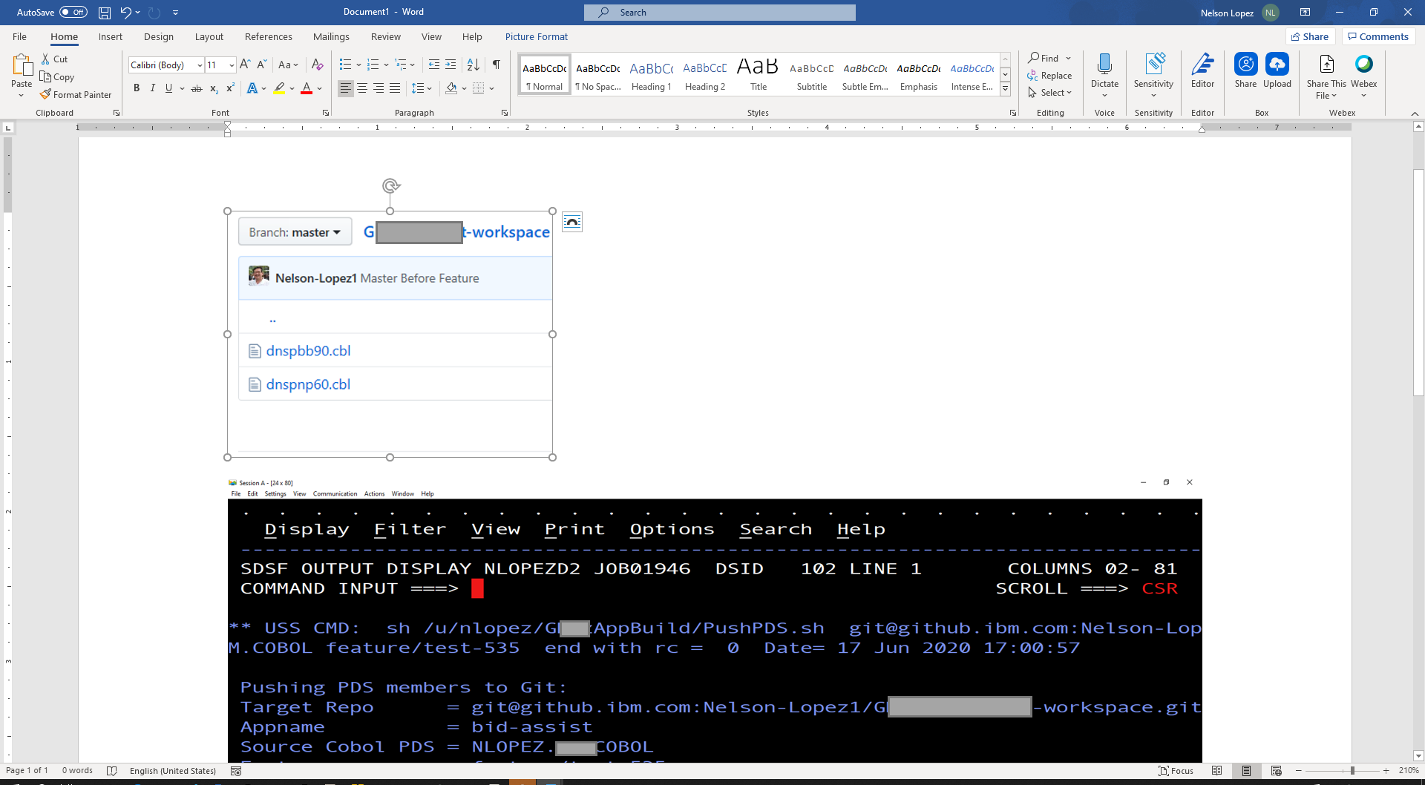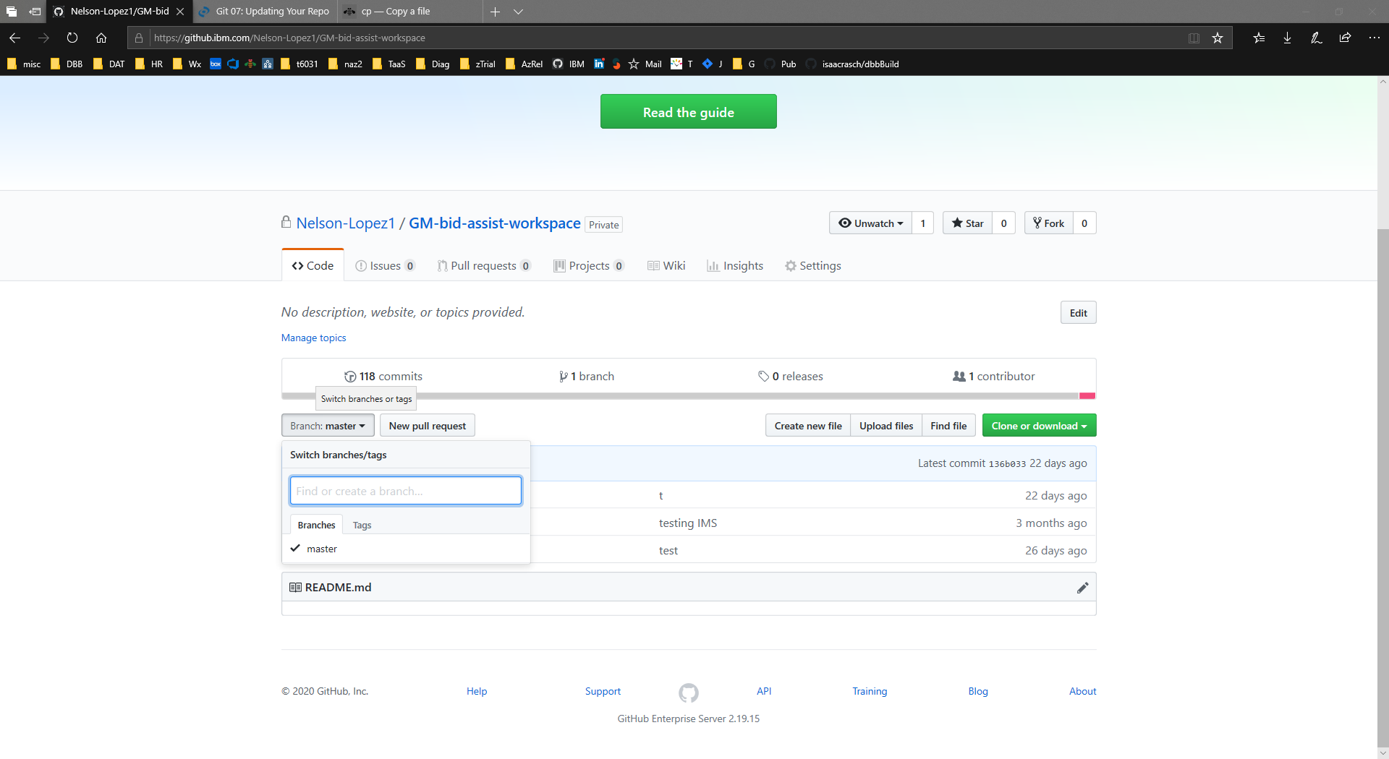

**Batch Job Results (partial sysout)**

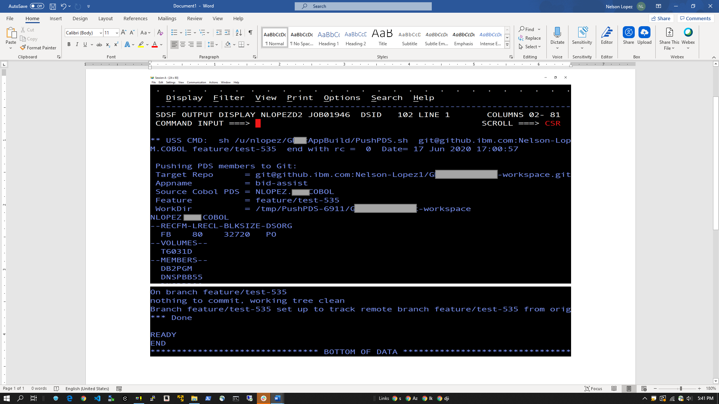

**Git Branch After - New Feature showing new cobol pgms. Ready for Pull Request**

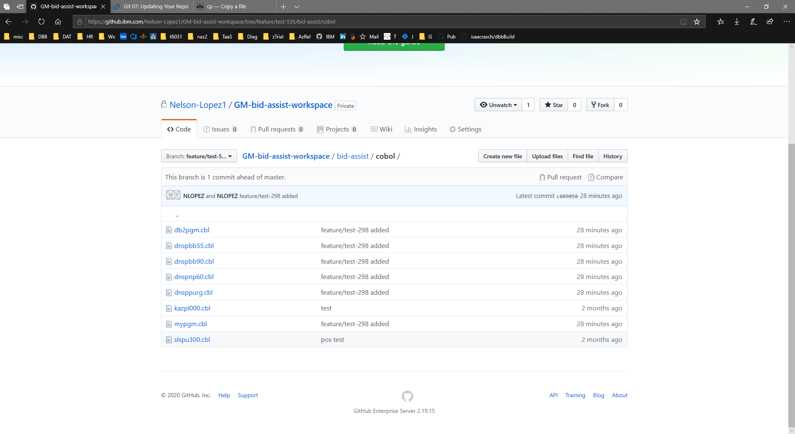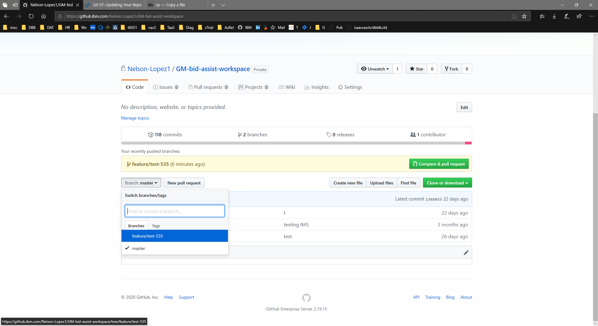

## RPP/RTC Notes

**Overview – proposed solution**

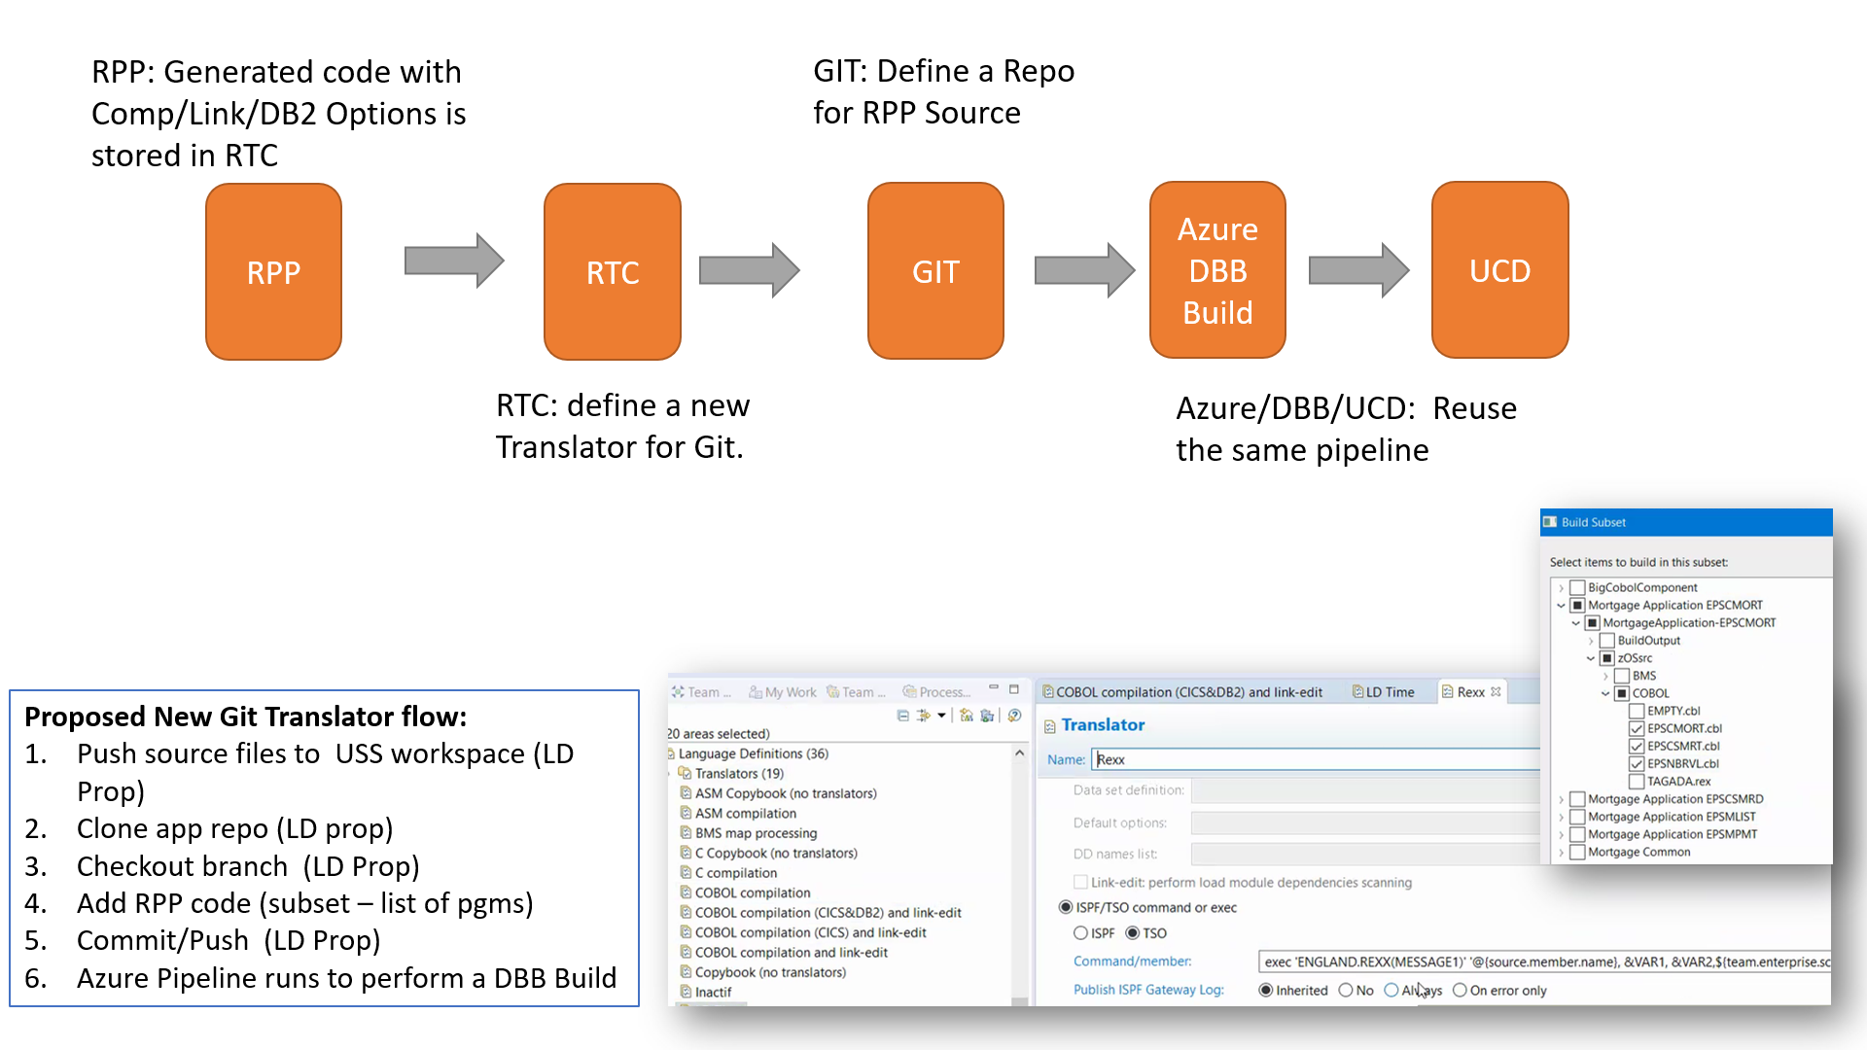

**End State**

